A probabilistic atlas of finger dominance in the primary somatosensory cortex

George C. O’Neilla†, Ayan Senguptaab†, Michael Asghara, Eleanor L. Barratta, Julien Beslec, Denis Schluppeckd, Susan T. Francisa*, Rosa M. Sanchez Panchueloa*

*aSir Peter Mansfield Imaging Centre, School of Physics and Astronomy, University of Nottingham, Nottingham, UK  
bWolfson Brain Imaging Centre, Department of Clinical Neurosciences, University of Cambridge, Cambridge, UK  
cDepartment of Psychology, American University of Beirut, Beirut, Lebanon   
dSchool of Psychology, University of Nottingham, Nottingham. UK*

**Abstract**

With the advent of ultra-high field (7T), high spatial resolution functional MRI (fMRI) has allowed the differentiation of the cortical representations of each of the digits at an individual-subject level in human primary somatosensory cortex (SI). Here we generate a probabilistic atlas of the contralateral SI representations to the digits of both the left and right hand in a group of 22 right-handed individuals. The atlas is generated in both volume and surface standardised spaces from somatotopic maps obtained by delivering vibrotactile stimulation to each distal phalangeal digit using a travelling wave paradigm.

Metrics quantify the likelihood of a given position being assigned to a digit (full probability map) and the most probable digit for a given spatial location (maximum probability map). The atlas is validated using a leave-one-out cross validation procedure. Anatomical variance across the somatotopic map is also assessed. This probabilistic atlas quantifies the variability in digit representations in healthy subjects and can be used as a reference in patient studies.

*Keywords:*  atlas, somatosensory cortex, digits, fMRI, ultra-high field

**Introduction**

Functional magnetic resonance imaging (fMRI) has proved to be a valuable tool for the non-invasive in-vivo study of orderly topographic organization of different cortical areas in humans, revealing the retinotopic organization of the visual cortex (DeYoe et al., 1996; Engel, 1997; Sereno et al., 1995; Wandell et al., 2007), topographic mapping of the tonotopic organization in the auditory cortex (Da Costa et al., 2011; Formisano et al., 2003; Moerel et al., 2018, 2012; Saenz and Langers, 2014) and the cortical representation of body parts (Akselrod et al., 2017; Sanchez Panchuelo et al., 2018), particularly the digits of the hand (Besle et al., 2013; Sanchez Panchuelo et al., 2010; Schweisfurth et al., 2015, 2014; Stringer et al., 2011; van der Zwaag et al., 2015) in the primary somatosensory cortex (S1). Due to the fine architecture of the cortical representation of the digits of the hand in the post-central gyrus (Geyer et al., 2000), somatotopic mapping is more challenging than retinotopic and tonotopic mapping, in terms of both the spatial resolution of cortical maps and the statistical power (Francis et al., 2000; Gelnar et al., 1998; Huang and Sereno, 2007; Kurth et al., 2000; Nelson and Chen, 2008; Overduin and Servos, 2004; Weibull et al., 2008). With the advent of ultra-high-field (UHF) MR scanners, operating at 7 Tesla (7 T) and above, high spatial resolution fMRI has provided robust maps of the representation of all the digits of the hand in primary somatosensory cortex in individual subjects (Besle et al., 2014, 2013; Martuzzi et al., 2014; Sanchez Panchuelo et al., 2010).

Inspired by recent work to generate probabilistic maps of visual topographic areas (Wang et al., 2015), this study aims to generate a probabilistic atlas of individual digit representations in the primary somatosensory cortex in both standard volume space and standard surface space. These probabilistic maps provide a method to define the likelihood of a given coordinate being associated with a particular functionally defined digit over a population of subjects, and so can be used to infer the localization of the digits in the primary somatosensory cortex of any independent data set. Probabilistic maps in healthy subjects provide a particular advantage in the somatosensory domain. Defining maps in individual subjects is often not feasible due to lack of specialised stimulation equipment, for example MR-compatible pneumatic or piezoelectric stimulators are required, and data must be collected at high field to enable sufficient spatial resolution to define the individual digits, else long scan times are required which can be limited by subject motion and the expense to a study.

To address this, here we have generate probabilistic digit somatotopic maps of each of the five digit in contralateral S1 from 7 T travelling wave fMRI data collected in 22 right handed subjects in response to vibrotactile stimulation tips of both hands (Besle et al., 2013; Sanchez Panchuelo et al., 2010) . The phase, amplitude and coherence of the best-fitting sinusoid at the stimulation frequency are estimated, and based on these phase maps, binary maps of each digit of the hand in each individual were generated. These binary maps were then transformed into both standardised surface space (Fischl et al., 1999b) and volume space (Collins et al., 1994) to generate a probabilistic atlas of digit representations in contralateral S1 in response to vibrotactile stimulation each of the hands. We then assess a number of metrics associated with these maps in both surface and volume space to determine the likelihood of a given spatial position being assigned to a digit (full probability map), the most probable digit for a given spatial location (maximum probability map), and use a leave-one-out cross validation procedure to validate the atlases. Reproducibility of the individual subject maps are assessed, and the degree of anatomical variance across the somatotopic map computed. These probabilistic atlases will be made freely available in formats compatible with major fMRI analysis packages.

**Experiment**

Functional MRI data were pooled from four studies (Barratt, 2018; Granga Espiritu Santo, 2018; Sanchez Panchuelo et al., 2018, 2016) collected from 2015 to 2018 all using the same 7 T Achieva MR system (Philips Healthcare; Best, Netherlands) using a head volume transmit coil and a 32-channel receive coil (Nova Medical: Wilmington, MA). Experimental procedures for all studies were approved by the University of Nottingham Medical School’s Ethics Committee. All subjects gave written informed consent and subjects had no history of neurological disorders.

To generate the digit probabilistic atlas, only those subjects who had completed somatotopic mapping of both the left and right hand were included. This resulted in the inclusion of data from 22 right handed healthy human subjects (equal biological sex distribution, age 29±9 years). In order to assess reproducibility of the somatotopic maps, four of these twenty-two subjects subsequently participated in an additional scan session to generate a second digit somatotopic map for both the left and right hand.

*Paradigm and acquisition*

Vibrotactile stimulation was delivered to a ∼1 mm2 area of the skin of the distal phalanges (fingertips) of the left or right hands using five independently controlled piezo-electric devices (Dancer Design, St. Helens, UK). A ‘travelling wave’ paradigm was used to sequentially stimulate each of the five digits of the left or right hand, in either a forward (from digit 1 to digit 5) or backward (from digit 5 to digit 1) ordering. Each vibrotactile stimulation lasted 4 s and consisted of bursts of 0.4 s duration at 30 Hz stimulation frequency separated by 0.1 s gaps (so as to limit habituation effects). A stimulation cycle across the five digits lasted 20 s. Functional scans consisted of 8-12 cycles and were repeated twice for each hand, alternating between forward and backward ordering. Table 1 provides details of the protocol used in each subject.

Functional MRI data were acquired using T2*-weighted, multi-slice, single-shot gradient echo–echo planar imaging (GE-EPI) at either 1.25 mm (n = 10) or 1.5 mm (n = 12) isotropic spatial resolution. 26 slices were acquired for the 1.5 mm isotropic resolution data. The 1.25 mm isotropic resolution data was collected using a Simultaneous Multi-Slice (SMS) factor of 2 to acquire 52 slices covering SI and SII. All other imaging parameters were identical: repetition time (TR) 2 s, echo time (TE) 25 ms, flip angle (FA) 75°, field of view of 192 x 192 mm2 in the anterior-posterior, right-left directions, SENSE acceleration factor 3 in the anterior-posterior direction. Functional runs were followed by the acquisition of a high-resolution, T2*-weighted axial FLASH image with the same slice prescription and coverage as the functional data (0.5 × 0.5 mm2 in-plane resolution; TE/TR = 9.3/458 ms, FA = 32°, SENSE factor = 2), acquired to allow subsequent registration to a structural whole head 1 mm isotropic resolution T1-weighted reference volume. For each participant, the structural T1-weighted anatomical image had been previously acquired using either a phase sensitive inversion recovery sequence (PSIR; Hou et al., 2005; Mougin et al., 2016; Van de Moortele et al., 2009; linear phase encoding order, TE/TR 3.7/15 ms, FA 8°, inversion times 778 and 2500 ms, tailored RF TR-FOCI inversion pulse; Hurley et al., 2009) or MPRAGE scan (linear phase encoding order, TI=996 ms, TE/TR 3.4/7.4 ms, FA 8°).

In addition to collection of MR data, all subjects completed the Edinburgh Handedness Inventory (Oldfield, 1971) to provide a measurement scale from which to assess the dominance of their right or left hand in everyday activities. Results of the quotient were converted into a handedness index (*H*),

$H=\frac{R-L}{R+L}$, (1)

where R is the number of activities on the inventory reported as performed right handed, and L is the number of left handed activities. A value of *H*=1 represents predominantly right handedness, whilst -1 would indicates predominantly left handedness.

**Table 1: *Details of subject’s handedness and protocol used.***

|  |  |  |  |  |  |
| --- | --- | --- | --- | --- | --- |
| **Subject ID** | **Handedness Index** | **Image Resolution / mm** | **Cycles** | **Reproducibility** | |
| **Resolution / mm** | **Cycles** |
| 001 | 1 | 1.5 | L:12 R:10 | 1.5 | 12 |
| 002 | 1 | 1.25 | 8 | 1.5 | 12 |
| 003 | 0.85 | 1.25 | 8 | 1.5 | 12 |
| 004 | 1 | 1.25 | 8 | 1.5 | 12 |
| 005 | 1 | 1.5 | 12 |  | |
| 006 | 0.2 | 1.5 | L:12 R:10 |
| 007 | 1 | 1.5 | 10 |
| 008 | 1 | 1.5 | 10 |
| 009 | 1 | 1.25 | 8 |
| 010 | 1 | 1.25 | 8 |
| 011 | 1 | 1.25 | 8 |
| 012 | 1 | 1.25 | 8 |
| 013 | 1 | 1.25 | 8 |
| 014 | 0.6 | 1.25 | 8 |
| 015 | 0.71 | 1.25 | 8 |
| 016 | 1 | 1.5 | L:12 R:8 |
| 017 | 1 | 1.5 | 8 |
| 018 | 0.41 | 1.5 | 12 |
| 019 | 1 | 1.5 | 10 |
| 020 | 1 | 1.5 | 12 |
| 021 | 1 | 1.5 | 12 |
| 022 | 1 | 1.5 | 12 |

**Data analysis**

A flowchart of the processing pipeline employed is shown in Figure 1, followed by a detailed description of the processing of the functional data to generate the atlas.

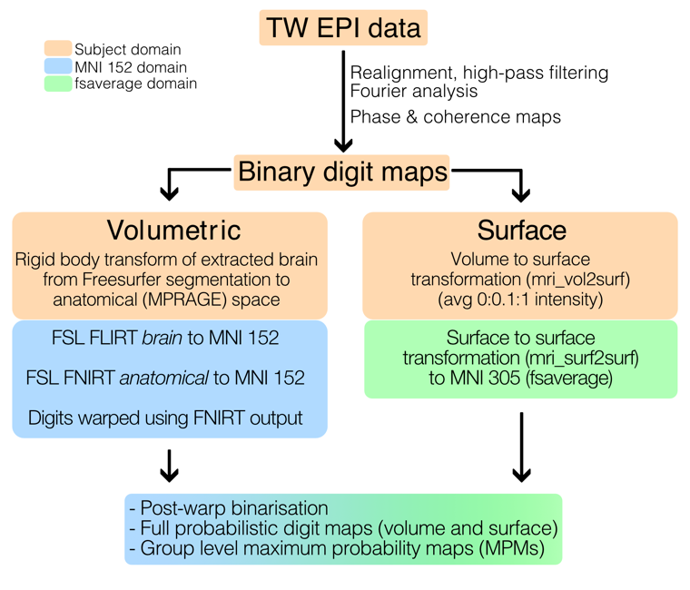

***Figure 1:*** *Flowchart of the analysis pipeline from the fMRI data collected using a travelling wave EPI (TW EPI) acquisition to the group-level probabilistic atlas of the digits.*

*Generation of subject-specific travelling wave maps*

The travelling wave fMRI datasets from each individual subject were analysed using mrTools (<http://www.cns.nyu.edu/heegerlab>). Functional MRI data sets were realigned to the last volume of the data set (reference EPI frame) acquired closest in time to the high-resolution T2*-weighted dataset. To account for scanner drift and other low-frequency signals, all time-series were high-pass filtered (0.01 Hz cut-off) and converted to percent-signal change for subsequent statistical analysis. The forward and backward travelling wave scans for the left and right hand were combined to cancel the haemodynamic delay (Besle et al., 2013). For each voxel, the corresponding time series were Fourier transformed compute the phase and amplitude of the best-fitting 1/20 Hz sine wave and the coherence between the time series and the best-fitting sinusoid. The phase and coherence statistical maps were then transformed from native functional data acquisition space into the subject’s whole-head anatomical space via a two-step procedure; the reference EPI frame was aligned to the in-plane T2*-weighted anatomical volume using non-linear alignment to account for any residual distortions in the functional volume, the in-plane T2*-weighted anatomical volume was inverted and then linearly aligned with the T1-weighted reference volume. All alignment steps were performed using an iterative, multi-resolution robust estimation method (Nestares and Heeger, 2000) as implemented in mrTools. Cortical segmentations were obtained from the whole head T1-weighted anatomical volume using Freesurfer v5.3.0 (Dale et al., 1999; Fischl et al., 1999a).

*Subject-specific digit ROI definition*

Once the phase and coherence maps had been transformed into the subject’s anatomical space, two stages of masking were applied to the phase data. The first stage involved statistical masking, based on the coherence maps. Here, the coherence maps were converted to p-values and a binary mask at p<0.05 (uncorrected) generated. A second stage of masking of the phase maps was then applied in which two methods were assessed defined as *manual* and *automatic* masking, with examples of each illustrated in Figure 2. In the *manual* case, the phase data were projected onto the cortical surface representing the midway between the white matter and pial surfaces within mrTools and the subject-specific mask was manually drawn on the surface so as to encompass all vertices whose phase shows an orderly representation of the digits. For the *automatic* approach, the subject specific Freesurfer labels of Brodmann areas 1, 2, 3a and 3b of the hemisphere contralateral to the stimulation were combined to form a mask of the entire somatosensory cortex. In either the *manual* or *automatic* approach, the surface-based masks were projected back into the volume space for masking of the volumetric phase data. Any voxels of the phase map which survived both the statistical and the *manual*/*automatic* ROI masking where then binned to generate subject-specific digit maps. Here, the individual digit ROIs were formed by dividing the phase map into 5 equally spaced bins each of 2π/5 width. Again, the binning approach is demonstrated in Figure 2. Note that the procedure of projecting either the *manual* or *automatic* masks back into volume space restricts these digit maps to the subject’s cortical ribbon.

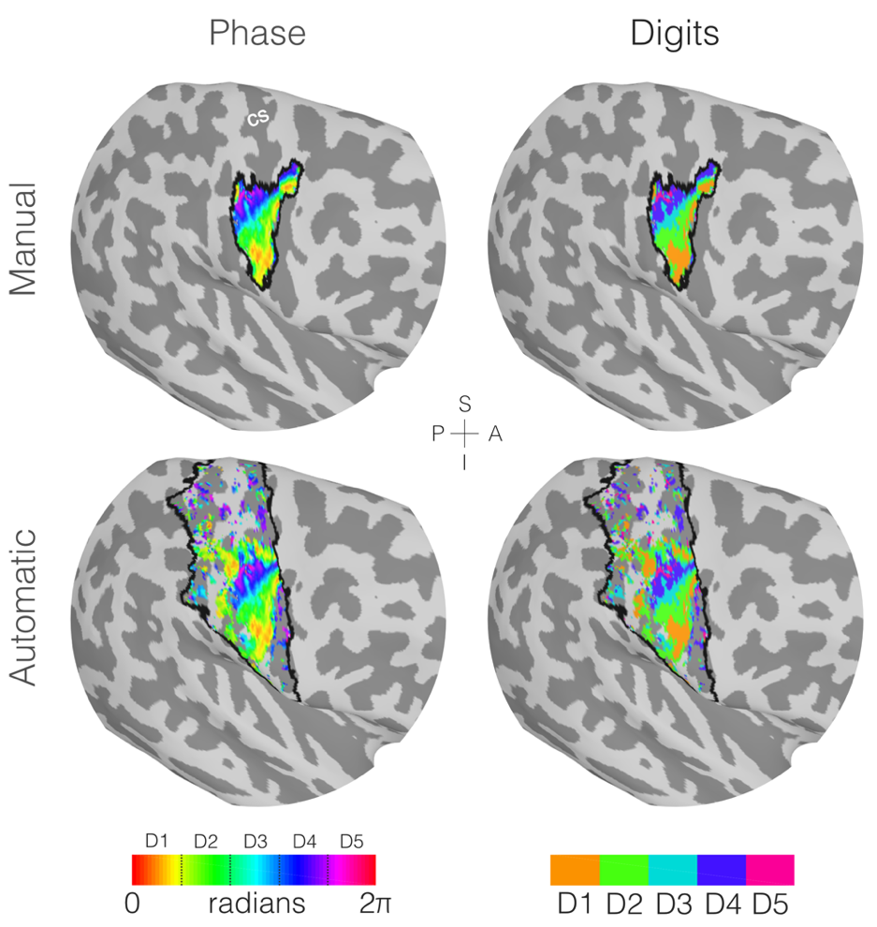

***Figure 2:*** *Example of the masking and phase binning process performed on the travelling wave data to generate the digit maps for the left hand of a single subject (Subject 003). For visualisation purposes this has been displayed in the subject’s contralateral inflated cortical surface, but note the final masking and binning process is performed in the volumetric MPRAGE space. Here light grey patches represent gyri and the darker grey patches the sulci. The central sulcus (CS) is labelled in white in the top left plot for reference. In all plots the mask boundaries are represented by the black lines, with the example of the manual mask on the top row and the automatic mask on the bottom row. Left column: phase maps generated from the Fourier analysis of the EPI data, with only the phase values which survive both the coherence masking and manual/automatic masking displayed. Right column: phases binned into binary representations of the individual digits, note the digit allocation for any given location is mutually exclusive in a single subject using this analysis method.*

*Reproducibility*

In four subjects, the reproducibility of the digit somatotopic (phase) maps was assessed across two scan sessions by computing the intersession phase difference for each voxel within the *manual* mask. Only voxels with coherence equivalent to an uncorrected p<0.05 across both sessions were considered. To assess reproducibility, the circular statistics toolbox for MATLAB (Berens, 2015) was used to test whether the phase difference was randomly distributed across all possible phase values or unimodal and centred around 0 using a V-test (Durand and Greenwood, 1958).

*Atlas generation*

After the creation of the subject-specific digit maps, the maps were transformed to standard spaces in both volumetric and surface space.

*Volumetric normalisation:*the extracted brain from Freesurfer was rigid body transformed using FSL’s Linear Image Registration Tool (*FLIRT*; Jenkinson et al., 2002; Jenkinson and Smith, 2001) to the subjects anatomical space[1]. Here a two-pass process was used to register the subjects anatomical to the MNI-152 space (2mm isotropic resolution). The first pass involved a linear registration of the extracted brain to the MNI brain using *FLIRT*, and then the resultant transformation was used as an initialisation step for a non-linear warp of the full anatomical (with skull) to the MNI brain (also with skull) using FSL’s *FNIRT*. The resultant warp field was then applied to the subject’s digit ROIs.

*Surface normalisation:*The digit ROIs were projected to the subject’s surface space using Freesurfer’s *mri_vol2surf*, using the average of projections at 0 % to 100 % the distance from the white matter to the pial in steps of 10 %. Next a surface-to-surface transformation to the MNI-305 (Freesurfer’s *fsaverage* subject) was performed with *mri_surf2surf*.

*Post-warp [re]binarisation:*After normalising to either volume-based or surface-based MNI spaces, it is vital to ensure that the mutual exclusivity of a digit at a given voxel/vertex in a single subject is still maintained. Both volumetric and surface pipelines violate this principle; the volumetric spatial normalisation process introduces ‘blurring’ of the binary images, as does the projection from volume to surface (where multiple voxels representing multiple digits are represented by a single vertex). Left unchecked, it is not unfeasible that the probability of *any* digit being represented at a given location of interest being larger than 1. To counteract this a ‘re-binarisation’ procedure was implemented on each of the subjects’ normalised digit ROIs. Here a winner-takes-all approach was implemented, where the most likely digit for a given voxel/vertex in a single subject was awarded the exclusivity of the region, but if, and only if, the probability of *any* digit existing there was larger than 0.5.

After normalisation and re-binarisation, two classes of probabilistic maps are generated as defined by Wang and colleagues (2015). Full probabilistic maps (FPMs) for each digit are defined as the number of digits assigned to a given voxel/vertex, normalised by the number of subjects. Using a winner-takes-all approach from each of the digit FPMs, maximal probabilistic maps (MPMs) were derived to assign digits to each location of interest. FPMs and MPMs were generated for the surface space and volumetric space with both the *manual* and *automatic* masked data.

*Atlas characterisation and validation*

In order to characterise quantitative metrics from each atlas we follow some of the methods previously described to assess visual topography to this somatosensory study by computing the blurring metric (Fischl et al., 1999b) and central tendency (Eickhoff et al., 2007).

The blurring metric provides a measure of how well ROIs from individual subjects overlap in a standard space. If a spatially normalised digit ROI from subject *k* is considered as a set $S_{k}$*,* where each element of the set are the voxel/vertices where a ROI exists, then the blurring metric, *B* for a given digit is

$B= 100\frac{\bigcup_{k=1}^{n}{S_{k}-\frac{1}{n}\sum_{k=1}^{n}{\left|S_{k}\right|}}}{\frac{1}{n}\sum_{k=1}^{n}{\left|S_{k}\right|}}$, (2)

where $\left|S_{k}\right|$ is the set cardinality, or number of elements in a set. Put simply, this is the percentage difference between total number of unique voxels/vertices where a digit may exist and the average spatial extent of a digit ROI across the group. A perfect overlap would return a blurring metric of 0.

The central tendency quantifies how much a single subjects digit ROI overlaps with high probability areas of the corresponding group-level FPM. If we assume the FPM is represented as a $1×n_{locations}$ vector $f$ and a subject’s binary digit ROI is vector of the same dimensions, $d$, the central tendency $P$ between the ith FPM and jth digit ROI is

$P_{ij}= \frac{F〈f_{i}∘d_{j}〉}{F〈f_{i}〉},$ (3)

where $∘$ is the Hadamard product and $F〈∙〉$ is a function which calculates the average of all absolute non-zero values within the triangle brackets. A value of $P=1$ implies perfect overlap, a value above 1 meaning it resides more centrally (i.e. over areas of high probability); below 1 would suggest the digit overlaps with the periphery of the FPM. The central tendency between all digits and all FPMs were calculated using a leave-one-out approach. In a single iteration, the FPMs were generated with 21 subjects and tested on the remaining subject.

*Anatomical Variability*

Since the probabilistic atlas of the somatotopic map conveys both functional and structural variability, anatomical variance alone was quantified. To assess the mutual alignment of subjects’ anatomy, maps of the mean and variance of the gyral and sulcal convexity across subjects was computed in standard surface space. The mean curvature and variance across the digit area (where the probability of any digit being represented is equal or exceeds 0.5; see Fig. 4A) was computed and compared to that exhibited in the primary and secondary visual cortex (V1, V2) as defined in Freesurfer.

**Data Availability**

Spatially normalised Digit ROI maps from the 22 individual subjects and group-level FPM/MPM atlases are available at <https://github.com/georgeoneill/digitAtlas>. Code to generate the group-level atlases is also available on the repository. Raw data and processing scripts can be made available on request, please contact either STF or RMSP to enquire.

**Results**

All participants were right handed as confirmed by the Edinburgh Handedness Inventory, Table 1 provides the handedness index for each individual. Handedness indices ranged from 0.2 to 1, with a mean of 0.89±0.05 (standard error). Figure 2 illustrates the travelling wave fMRI maps on a single example subject (Subject 003). Analysis reveals cortical areas with high digit specificity (high coherence) located on the postcentral sulcus and the posterior bank of the central sulcus, corresponding to the contralateral primary somatosensory cortex (S1). These maps show an orderly phase pattern ranging from low (digit 1) to high (digit 5) values following the main inferior/superior direction of the central sulcus (and lateral/ medial direction given the orientation of the sulcus in the coronal plane). In this particular subject, we also observe high coherence and phase ordering in the primary motor cortex (M1); an effect which was observed in 50 % of subjects (11). Note that the use of the *automatic* masking method will disregard this area of activation as it occurs in Brodmann area 4.

Phase maps are highly reproducible across subjects, as illustrated here by the high degree of reproducibility of the results from the four subjects who participated in two scan sessions for both the left and right hand (Fig. 3). The distribution of the inter-session phase difference values in the *manual* hand ROI mask for each subject was significantly non-uniform and distributed around 0 (V test, V=2116±596 and 3090±262 [mean ± standard deviation across subjects] for both the right hand and left hand digits respectively, p < 10-16). This illustrates the high reproducibility of phase maps between scanning sessions even when the spatial resolution of the fMRI data within a subject differed (1.25 mm and 1.5 mm isotropic voxels).

Figure 4 shows the full probabilistic maps (FPMs) for any (Fig. 4A) and each digit (Fig. 4B) of the left and right hand. Figure 4A shows the probability of any digit being assigned when *manual* masking is applied using the surface-based pipeline, with boundaries shown in black where the probability exceeds 0.5 (defined to be the ‘*digit hand ROI’*). We observe the highest probabilities in the posterior bank of the central sulcus (CS) corresponding to primary somatosensory cortex (S1). In the left and right hands, we observe 100% overlap across all subjects (n=22). Individual digits FPMs for both the *automatic* and *manual* masks on the surface-based pipeline are shown in Figure 4B. Both methods can be seen to yield similar maps with the FPM from D1 to D5 following the expected lateral-to-medial organisation along the central sulcus. Note that the *automatic* masking method allows for digit assignment to any region within S1 and this is reflected by the larger spatial extent of low probability values compared to the *manual* masking. In the top right corner of each FPM plot, the maximal number of subjects (of the 22 included in this probabilistic map) with overlap for a given digit is provided. Here we see that the peak overlap is similar across both the *manual* and *automatic* masking, with a maximum of 17 for left D2 (*automatic* masking) and the lowest, 7, occurring for right D5 (*manual* masking). For comparison, the results of the volumetric-based pipeline can be found in the supplementary material, for which we observe a similar digit organisation, but with lower maximal overlap across subjects across all digits (left D2, *manual* = 14; right D5, *manual* = 4). To simplify the results, we shall from this point forth only discuss the results of the *manual* masked data, with *automatic* masked data and volumetric plots of the atlas provided in supplementary material.

Figure 5A (left column) shows the maximum probability maps (MPMs) for the right and left digits (surface analysis, *manual* masking), again showing the lateral-to-medial organisation of the digits, particularly over Brodmann area 3b. Figure 5A (middle column) shows the group circular-average of the phase maps, masked to show only those locations found in the MPMs. It can be seen that the progression of low to high phase values are organised in a similar fashion to the MPMs, however there is a negligible representation of both D1 and D5 phases when averaged across the group. This is particularly highlighted in Figure 5B which plots the average phase value for each subject where a specific MPM ROI interacts. It can be seen that whilst a monotonic increase is seen in the median values of phase with each digit, only the median phase of digits 2, 3 and 4 falls within the expected ranges (e.g. D2 in single subject is defined by a phase between 0.4π and 0.8π, and this is reflected in the group median). The lack of phase definition for digits 1 and 5 reflects the information lost by simply averaging phases across the group. Finally, Figure 5A shows the circular standard deviation of phase across the subjects within the MPM regions, the left digits have an average circular standard deviation of 1.08 radians and the right digits of 1.22 radians.

Figure 6 shows the spatial extent of the individual subject digits when transformed to a standard space in both surface (Fig. 6Ai and 6Bi) and volumetric (Fig. 6Aii and 6Bii) space, both manually masked. Note that for surface ROIs these are projected to Freesurfer’s *fsaverage* white matter surface, and surface areas will slightly vary depending on the cortical surface of choice. Pink bars represent the group averaged spatial extent of each digit whilst the blue bar is the spatial extent of the corresponding MPM. A two-factor ANOVA reveals a statistically significant effect of digit allocation to ROI sizes (surface: F(4,210) = 26.32, p=1.06 × 10-17; volume: F(4,210) = 19.90, p=6.60× 10-14). No effect of hand allocation was found (surface: F(1,210) = 0.41, p=0.52; volume: F(1,210) = 0.03, p=0.86) nor an interaction between the digit and hand allocation (surface: F(4,210) = 0.1, p=0.98; volume: F(4,210) = 0.31, p=0.87). Since there was no significant difference in hand allocation between left and right, post-hoc testing was performed on data from both hands combined. Figures 6Ci and 6Cii highlight where significant differences in digit sizes occur respectively for surface and volume analysis, with the p-values of significant differences depicted in matrices. In short, we observe that the size of D5 is considerably smaller than all other digits in both the surface and volumetric maps, whilst D3 is smaller than D1 and D4 in surface space. The MPMs sizes (blue bars) follow a similar trend to the group averages, particularly for the left digits. However, we observe in the surface-based analysis that the size of D4 in the MPM is notably larger than the group average size, whilst D5 is markedly smaller in all cases.

Validation results are provided in Figure 7. First, the blurring metric (Fig. 7A) shows the highest overlap (i.e. lowest blurring metric) in D4, followed by D2, D1, D3, with D5 displaying a much higher blurring metric compared to the other digits. We also see that the blurring metric for the surface maps is lower than their volumetric counterparts, which conforms with previous studies (Fischl et al., 1999b; Wang et al., 2015). Leave-one-out validation results are depicted as the matrices of the average central tendency results from all 22 iterations of the FPMs and MPMs. For the FPMs (Fig. 7B), it can be seen that, in most cases, the diagonal element of the central tendency matrices is the largest in each row, implying that the FPMs built from 21 subjects show high overlap with the ROI locations of a novelsubject. This is the case for all digits other than D5 in both hands (both in the surface and volume representations), whereas the central tendency for D4 is the dominant value, suggesting that the FPM for D4 regularly overlaps with a subject’s D5. In the volumetric case, we see that a novel D1 corresponds with the left D2 FPM better than the left D1 FPM. When assessing the leave-one-out results for the MPMs (Fig. 7C), there is a less clear picture. Note that due to the MPMs being binarised representations, the central tendency will never exceed 1, and so comparisons cannot be directly drawn between the FPM scores and the reduced MPM scores. That aside, we see that fewer subject digits show the highest overlap with the corresponding MPM ROI. Rather than 8/10 diagonal elements in the FPM (Fig. 7B) showing the highest central tendency value for each row, in Figure 7C we see that this is only the case for 4/10 digits (surface case, Fig. 7Ci) and 5/10 (volume case, Fig. 7Cii) respectively. Here in particular it becomes apparent that since the surface MPM D4 is considerably larger than other digit areas (c.f. Fig. 6), it overlaps with many subjects’ D3 and D5 ROIs. Note also, that due to the almost negligible size of D5 in the MPMs, the central tendency score of any digit with D5 is close to zero.

Finally, the results of the analysis of the anatomical variability are shown in Figure 8. Figures 8Ai and 8Bi show the mean and standard deviations of curvature over the cortical surface, whilst Figures 8Aii and 8Bii show the histogram of three test ROIs of digit areas (red), V1 (green) and V2 (blue), normalised by the total number of vertices in each ROI. We observe that the range of curvature values are similar across all three ROIs, whilst Figure 8Bii shows that the digit ROIs distributions (median standard deviation = 0.091) have reduced curvature variability compared to V1 (median standard deviation = 0.127) and V2 (median standard deviation = 0.163).

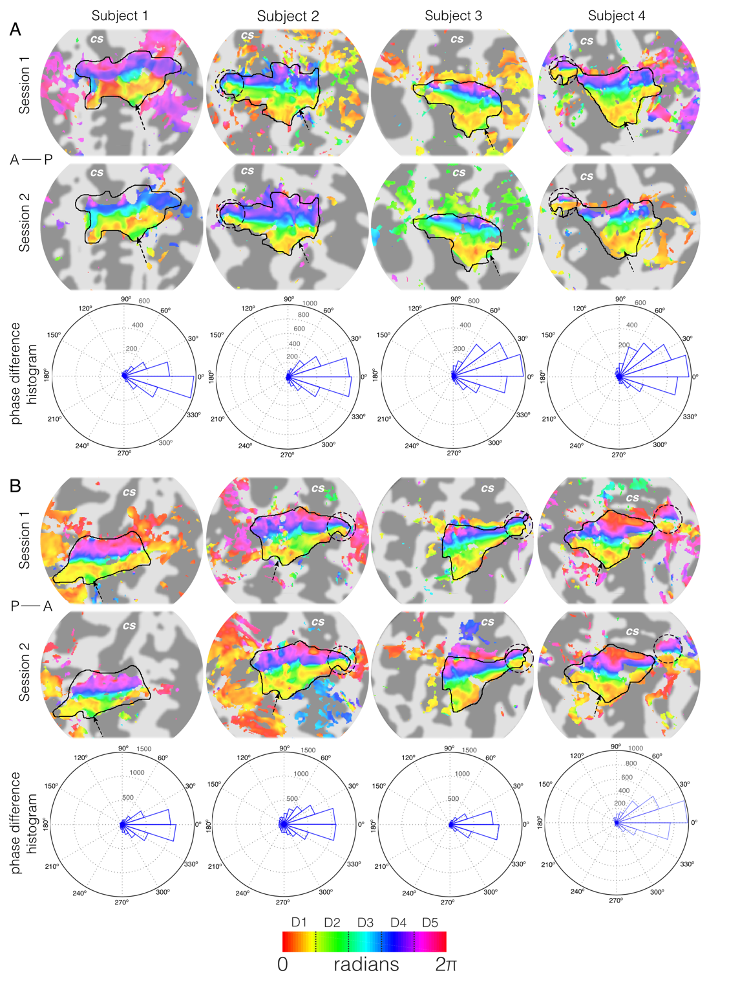

***Figure 3:*** *Reproducibility of digit somatotopic maps for (A) right hand and (B) left hand. Phase activation maps (displayed at coherence value of 0.3) from data acquired in two separate scanning sessions onto flattened representations of the contralateral central sulcus. Session 1 (first row) data acquired at 1.25 mm isotropic resolution for all subjects except Subject 1 (1.5 mm isotropic resolution). Session 2 (second row) data acquired at 1.5 mm isotropic resolution. Dark grey, areas of negative curvature (sulci); light grey, areas of positive curvature (gyri). An orderly representation of the digits is seen in the posterior bank of the central sulcus (CS), corresponding to S1. The black outline shows the manual delineation of the cortical surface for the hand digits. Third row: Corresponding histograms of voxel-wise phase differences between travelling-wave scanning sessions. Note the similar pattern of responses despite different spatial resolution. In some subjects we have extra features, either a full representation of the digits in the primary motor cortex (dashed circles) and some have a secondary area for D2 which surrounds D1 (dashed arrow).*

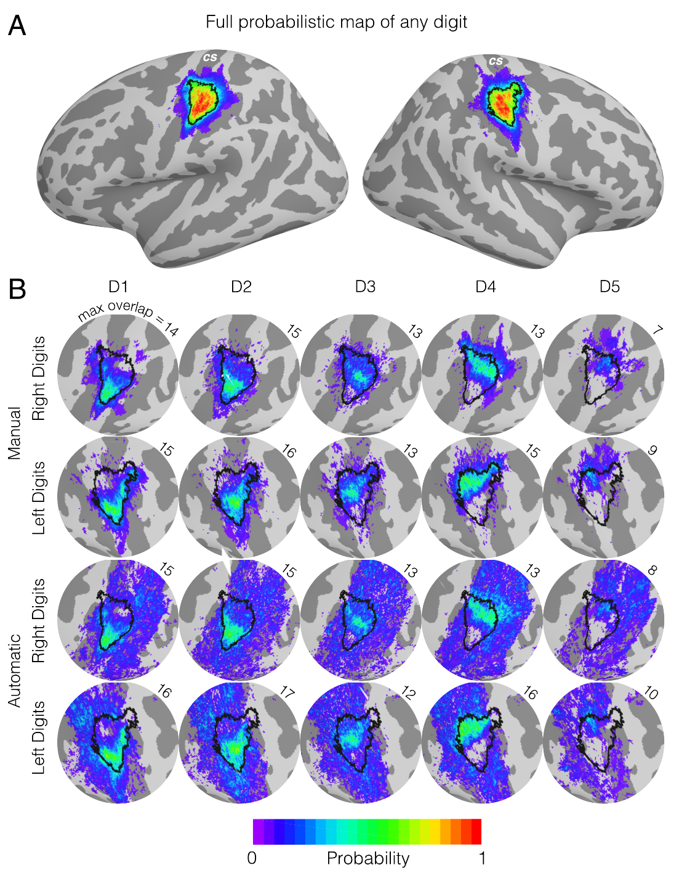

***Figure 4:*** *Full Probabilistic Mapping (FPM) for a surface-based atlas of the digit areas of the hand on an inflated cortical surface. Dark grey cortical regions represent sulci, whilst light grey represent gyri. A) The summation of all 10 digits to show the FPM of the canonical digit area, showing the largest areas of highest probability are in the central sulcus and postcentral gyrus. The black boundaries represent the 50 % probability threshold of any digit being represented there, with the enclosed ROI being referred to as the digit hand ROI henceforth. B) Zoomed-in representations of the central sulcus, with the corresponding digit area to that hemisphere overlaid as a reference marker. Each sub panel represents the FPMs for each individual digit for both the manual and automatic masking. The number in the top right corner of each sub panel shows the maximal number of subjects which overlap.*

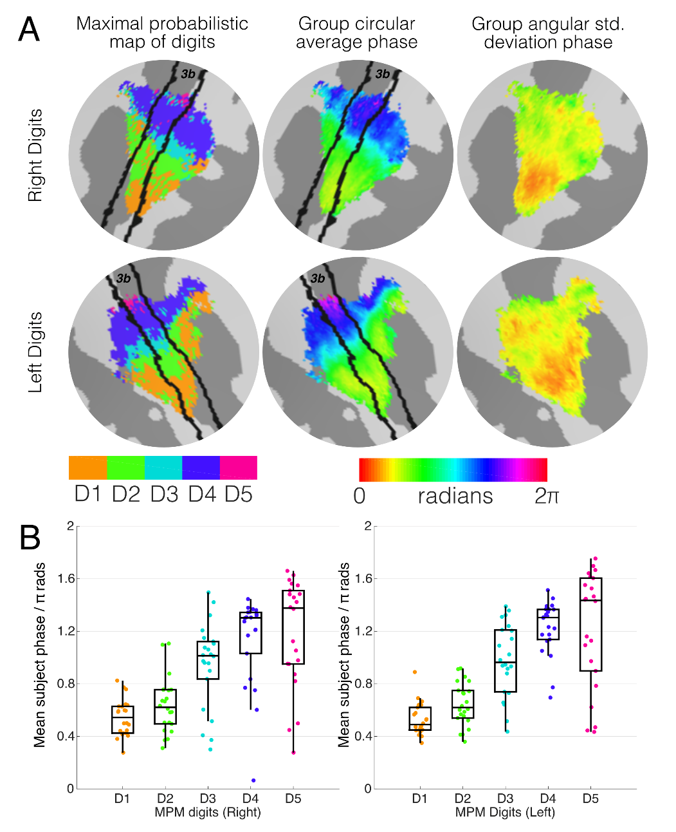

***Figure 5:*** *The relationship of the Maximal Probability Maps (MPM) to the group-level phase results. A) Left column: the MPMs for the digit areas based on the winner-takes-all approach, showing the lateral-medial organisation of the digits. Overlaid is Freesurfers Brodmann area 3b label for anatomical reference (black lines). Middle column: the subject circular averaged phases derived from the Fourier analysis of the original functional data, masked to contain only the regions represented by the MPMs. Right column: angular standard deviation of the groups phases, showing lower variabillity in the left digits (averaging 1.08 rads across the ROI) compared to the right digits (1.22 rads). B) The relationship between the MPM ROIs and the subjects phase maps it intersects with, each dot representing the mean phase for a subject over that ROI in MNI space. The boundaties between digits allocations have been overlaid as grey horizontal lines. The median of the subject distributions for digits 2, 3 and 4 all fall within the expected boundaries.*

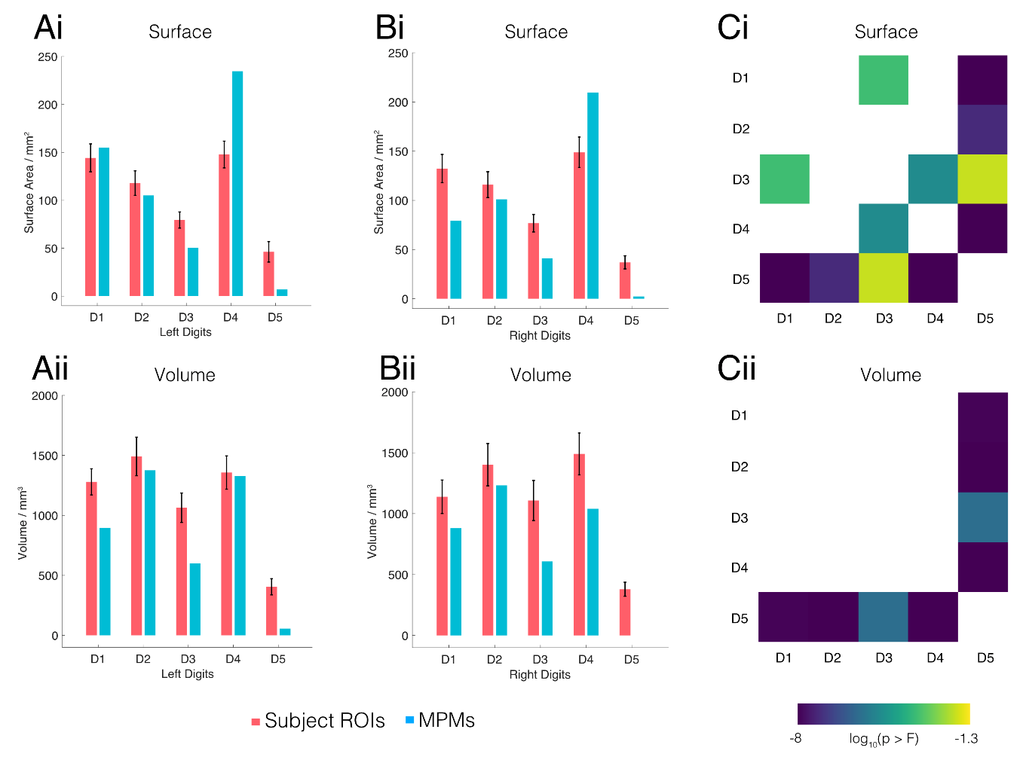

***Figure 6:*** *Digit ROI size results, surface-based results are shown on the top row and volume-based on the bottom. A) A comparison of the subject left digit ROIs (pink bars) when projected to MNI spaces compared to the resultant MPM ROIs, error bars (black) represent the standard error of the mean. Blue bars represent the size of the corresponding MPM ROI. B) the same as panel A but for the right digits. C) The results of the post-hoc testing on where differences in the spatial extent of digit representations occur, the matrices contain log-transformed p-values of null hypothesis that the labelling of the digits doesn’t affect the size of digit ROI. Values less than -1.3 (log10(0.05)) are displayed showing in all cases that D5 is significantly smaller in representation than the rest of digits.*

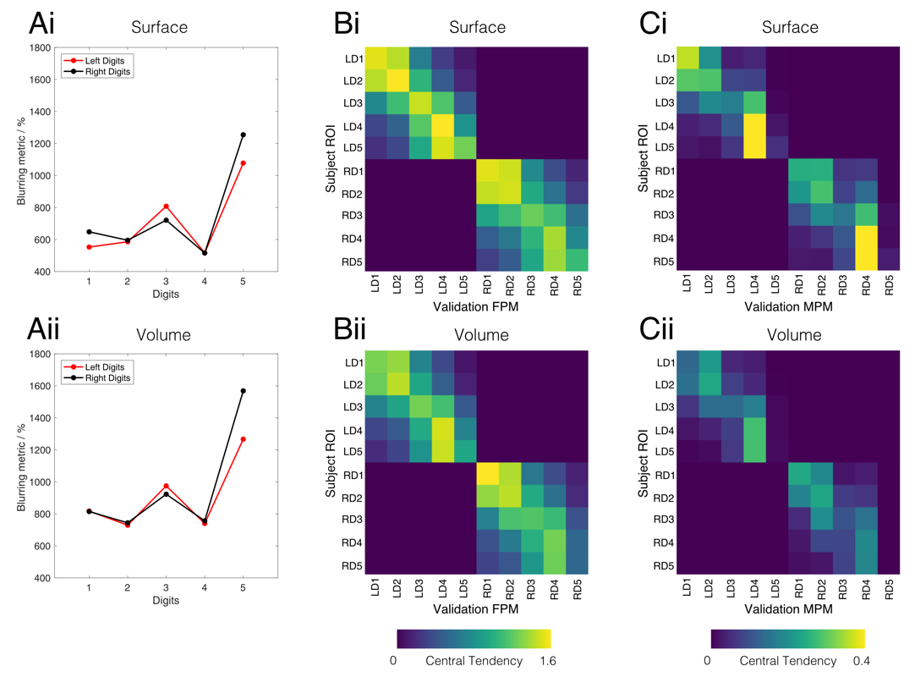

***Figure 7:*** *Characterisation and validation results of the probabilitic maps in both surface space (top row) and volume space (bottom row). A) Blurring metric results for the digit ROIs after spatial normalisation; lower scores indicate a better overlap of the ROIs across normalised subject maps. Here, we observe that the ROIs in surface space yield lower blurring scores compared to their volumetric counterparts. B) Central tendency scores from FPMs generated using the leave-one-out method, with the average scores from all 22 permutations shown. We observe a strong diagonal element to these matrices, with the central tendency scores being highest along the diagonal for a given ROI in 8/10 digits for the surface ROIs and 7/10 for the volumetric ROIs. C) The average central tendency score for MPMs generated using the leave-one-out method.*

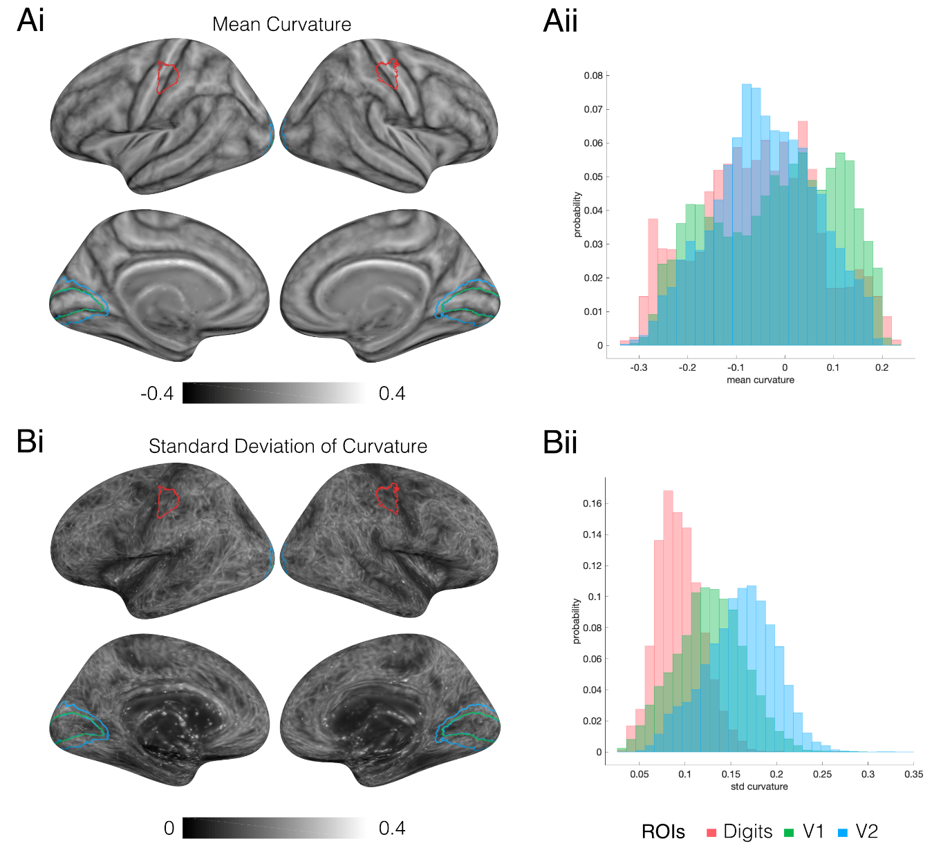

***Figure 8:*** *Results of the anatomical variability in the surface domain. Ai) Maps of the subject averaged surface curvature after transformation to the MNI-305 space, the ROIs for the digit area, V1 and V2 are shown on the surfaes in red, green and blue respetively. Aii) Nomalised histograms show the likelihood distrubtions of curvature within the given ROIs, showing that the gamut of curvature values is similar across the three ROIs. B) Maps of curvature variability, as represented using standard deviation. Bii) Normalised histograms of curvature varibility within the three ROIs, showing that anatomical differences within the digit area in S1 are notably lower than for V1 and V2 areas.*

**Discussion**

Here, we present a probabilistic volume- and surface-based atlas of digit somatotopy defined from functional MRI. These somatosensory maps are derived from finger dominance (binned phase maps) and are highly reproducible across subjects (Fig. 3). We compute two probabilistic maps, one based on the Full Probabilistic Maps (FPM) for each hand ROI and individual digits, and the second using Maximum Probabilistic Maps (MPM) for the right (dominant) and left (non-dominant) hand in contralateral S1, based on a *manual* and automated method of masking hand areas.

*The effect of Surface versus Volume normalisation on FPMs*

In the FPM, we observe for both the left and right digits a clearly defined ‘digit hand ROI’, with a 50 % or greater probability of any digit being represented in both surface space (Fig. 4) and volume space (Supplementary Material). Furthermore, we observe regions that overlap 100 % across all subjects in surface space and 95 % in volume space. Within the ‘digit hand ROI’, the FPM of individual digits (D1-D5) shows a clear lateral-medial organization in contralateral S1 and the variability of individual digit representations across subjects (Fig. 4). We also observe that individual digit overlaps are generally greater in the surface atlas than in the volume atlas, which are tabulated for comparison in the Supplementary Material. This may be in part due two factors: 1) surface-based normalisations provide better data registration to a standard template (here *fsaverage*), and therefore offer better overlapping group data (Aquino et al., 2019; Fischl et al., 2008, 1999b; Lerch et al., 2017; Wang et al., 2015), which we corroborate in this study from our blurring metric (Fig. 7). 2) the cortical surface offers a finer spatial resolution than the 2mm volumetric brain - the total of ~328,000 integration points over both cortical surfaces compared to ~228,000 over the entire brain volume (including cortex, sub cortex, cerebellum and brainstem) offers considerable finer sampling resolution to investigating overlapping representations.

*The effect of automatic versus manual masking on digit dominance*

We also assessed how the masking of the travelling wave data affects the digit maps, either by *manual* or the *automatic* pooling of primary somatosensory Brodmann areas (1, 2, 3a, 3b). Figure 4B shows both mask types produced comparable areas of higher probability, however *automatic* masking yields a larger spatial extent. This can be seen for a single subject (Fig. 2), where the *manual* ROI is mostly enclosed within the *automatic* masked area, leading to similar phase and binned digit maps within that core region. However, the *automatic* method has two distinct drawbacks; first, the lack of specificity to body site means that the spatial extent of each digit in the MPMs span almost the entire primary somatosensory cortex (large areas of deep blue and purple (low probability) in Fig. 4B), second, a rigid definition of S1 means that some functional areas are consistently activated are overlooked such as the section in primary motor cortex (M1), which has a full coherent representation of digits in only half of subjects (Fig. 2 and Fig. 3). This has been observed in previous high spatial resolution studies (Besle et al., 2014, 2013; Sanchez Panchuelo et al., 2010), and we suggest that this reflects genuine localisation of function, rather than an unfolding artefact, especially given the much smaller spatial extent in M1 containing the entire range of phase values.

*Digit allocation in MPMs*

Maximal probabilistic mapping (MPMs) allow us to generate sharp boundaries between digits at the group level (Fig. 5, with volumetric FPMs and MPMs shown in Supplementary Material). Digits D1, D2, and D4 show a larger representation than D3 and D5. D5 representation is particularly small, with the size of the MPM D5 area being notably smaller than the group mean size of the D5 ROI across subjects (Fig. 6), while D4 is considerably larger. We believe that these effects result from a low spatial overlap for D5 across subjects and a large overlap in D4. For example, in the right hand, the maximal probability of a vertex representing D5 is 0.32, whist for D4 this rises to 0.59. Consequently, the winner-takes-all digit allocation in an MPM means that higher overlap values for D4 allow it to expand into D5 territory. There is also the possibility that D5 should extend more medially than it does in the MPM, but due to low overlap across subjects, it does not satisfy the classification for digit assignment (i.e. probability of *any* digit being allocated at a given location exceeding 50 %). Figure 5 shows the group-level phase map generated from the circular mean of the individual travelling wave maps, these show a similar progression of phase in close keeping with the MPMs. Indeed, when comparing the phase values for each spatially normalised subject to the MPM, Digits D2, D3 and D4 are all in close agreement, with their median phase distribution falling into the expected phase bin (Fig. 5B). However, this is not true for D1 and D5. In a large number of subjects (n=14 and n=12, right and left hand somatotopy respectively), there is an additional region responding preferentially to D2 inferior to the representation for D1 (data not shown). In Figure 3, we observe that there are cortical patches which are inferior to D1 that clearly have phase values associated with D2 (see dashed arrows), implying that D2’s functional digit dominance ‘sandwiches’ D1. This has been seen in previous travelling-wave somatotopy studies (Besle et al., 2014), and in event-related analyses of the digit representations, these inferior D2 areas were significantly activated by all digits, but with the highest statistical significance for both D1 or D2. It is this ambiguity between dominance of D1 and D2 which we believe drives the inflated values of phase. Additionally, it can be seen in Figures 7B and 7C that the central tendency scores for D1 and D2 are very similar; consistent with a high degree of overlap between D1 and D2 representations. This separation ambiguity reinforces a receptive field superposition effect. Despite the oversimplification of digit representations made by the MPM, generating MPM boundaries based on the FPM is more informative than simple group-averaging of phase maps. For D5, this can be explained by the small receptive field size of D5 and the large spatial variability (poor overlap, see high blurring metric values in Fig. 7) across subjects. For D1, this phase misalignment is a more curious result given its good overlap and large spatial extent. We believe that the inflated phase values in the group-level D1 ROI are due to the superposition of D1 and D2 receptive fields.

*FPM and MPM atlas validity*

Figure 7 shows the results of quantifying how well subjects are aligned to each other and how generalisable the atlas is for a novel subject. Blurring metric results show that the surface based atlas has overall less blur across individual subject maps than the volumetric counterpart, in line with previous observations (Fischl et al., 1999b; Wang et al., 2015). Comparing digits within the same atlas we observe that there is a strong anti-correlation between average digit ROI size and blurring metric (surface atlas: r=-0.934, p=7.3 × 10-5; volume atlas: r=-0.956, p=1.7 × 10-5). This finding explains why D5 has a considerably higher blurring metric compared to the rest of the digits, it is difficult to reliably align an area which is on average 0.5 cm2 across a cohort. We also observe a similar effect with D3 (smaller ROI area, lower overlap, higher blurring metric). The leave-one-out validation results (Fig. 7B and 7C) show in most cases the diagonal element of the central tendency matrices is the largest in each row, implying that FPMs generated from 21 subjects show high overlap with the ROI locations of a novel22nd subject. This is the case for all digits other than D5 in both hands (and both the surface and volume representations), where the central tendency for D4 is the dominant value. Note it is feasible that the higher probability values within the D4 FPM may be introducing a bias here; it is possible that the blurring metric value for an ROI centred over the centre of the D5 FPM may still return a lower central tendency score than a ROI in the distal regions of D4 given the lower peak probability values in D5. This bias could be addressed by scaling the probabilistic maps into likelihood maps, where peak probabilities are scaled to be equal to 1, but the consequence of this is that MPMs cannot be generated from the scaled maps. In the volumetric case, we see that a novel D1 corresponds with the left D2 FPM better than the left D1 FPM, which may be due to the volumetric spatial normalising blurring the aforementioned ‘sandwiching’ effect of D2 around D1. When assessing leave-one-out results for the MPMs (Fig. 7C), there is a less clear picture, highlighting the oversimplification of the MPM procedure.

*Structural versus functional variability*

The probabilistic atlas can be influenced by inter-subject variability to both functional organization, but also structural variation across the somatosensory cortex of individual subjects (Fig. 8). Within S1, it has been shown that there is high inter-subject variability of the cytoarchitectonic boundaries of Brodmann areas (3a, 3b, 1 and 2; Geyer et al., 2000). However, we show that for the S1 hand area (ignoring boundaries across S1 Brodmann areas), after the process of normalization to the standard template, the anatomical variability (quantified by gyral and sulcal convexity) is relatively minimal, as compared to that in the visual cortex (Fig. 8Bii). This result suggests that the inter-subject variability influencing the probabilistic maps can largely be attributed to variations in functional topography rather than anatomical misalignment.

*On the use of finger dominance paradigms*

It is worth noting that due to the nature of the travelling wave paradigm used here, the probabilistic maps provided relate to digit dominance rather than cortical digit representation. The Fourier analysis provides maps of the phase of the BOLD responses relative to the stimulus, with the phase corresponding to a unique specific location of the stimulus; hence cortical areas that may respond to multiple digits are assigned to a single digit. In previous work we have used an event-related design to reveal the spatial overlap of the digit representations in individual subjects (Besle et al., 2014, 2013). We showed that the BOLD response within cortical regions preferentially responding to a given digit ROI (defined by the travelling wave design) is also significant for the adjacent digits (Besle et al., 2014), with most posterior parts of S1 responding to up to 5 digits. Digit maps defined from an event-related design are expected to be larger in extent than the digit map from a travelling wave design, and hence probabilistic maps of cortical digit representations would likely be larger than digit dominance maps due to larger digit representations in individual suggest resulting in higher overlap across subjects. However, the travelling wave design is more efficient than the event-related design for mapping digit specific responses in S1 (Besle et al., 2013), allowing mapping of all digit representations in a faster (by a factor of 3 to 4) time than an event-related design, and hence more suitable to study clinical populations, where short scanning times are recommended.

**Conclusion**

The probabilistic maps generated here provide a method to define the likelihood of a given coordinate being associated with a particular functionally defined digit over a population of subjects, and so can be used to infer the localisation of the digits in the primary somatosensory cortex of any independent data set. The cross-validation analysis shows that the FPM is a useful predictor for individual digit S1 representations in novel subjects who do not contribute to the atlas creation, albeit with a large overlap between D1 and D2. In contrast, the MPM was not generally predictive of single subject digit ROIs for novel subjects. However there are cases where the MPM may be preferred, for example where you need hard boundaries between digit ROIs. In support of this, the group-level MPM and FPM atlases and spatially normalised individual subject maps are available at <https://github.com/georgeoneill/digitAtlas> and this will be periodically refined by adding participants from future studies using the same experimental paradigm.

**Acknowledgements**

This work was funded by an MRC grant Medical Research Council [grant number MR/M022722/1] and a Leverhulme Early Career Fellowship to Rosa Sanchez Panchuelo. We would like to thank Miguel Granja Espiritu Santo for help with the initial data analysis.

**Appendix – Application of atlas to electrophysiological data**

As mentioned in the discussion, one of the purposes of the atlas is to assist in informing the sources of functional data in situations where precise knowledge of a subject’s digit areas are not available. For example, in electrophysiological imaging modalities such as magnetoencephalography (MEG) and electroencephalography (EEG), it is possible to localise digit areas using somatosensory evoked fields/potentials (Nakamura et al., 1998) but often requires hundreds, if not thousands of repeats of transcutaneous stimulation per digit from either electrodes (Meunier et al., 2001) or pneumatic stimulators (Jamali and Ross, 2013). This can be time consuming and in the case of the electrical nerve stimulation, often uncomfortable. If the atlas can be demonstrated to offer guidance on the somatotopic organisation of function from other experiments or perhaps be used as a spatial prior, then it has potential utility in functional studies.

Intraneural Microstimulation (INMS; Torebjörk and Ochoa, 1980; Vallbo, 1981) is the process of delivering a microampere-level stimulation to a single 1st order interneuron within an afferent nerve bundle, by inserting a laminated electrode subcutaneously and placing the exposed tip into a single axon. It allows us to probe haptic touch at the quantal level; stimulation of the nerve gives and haptic sensation at the site of the mechanoreceptor and a functional response in the somatosensory cortex (Trulsson et al., 2001). It has been shown that in an fMRI study where participants when INMS of the median nerve at 7.0 T and had their digits mapped using a travelling wave paradigm that the areas of maximal functional activation occurred within the expected digit areas (Sanchez Panchuelo et al., 2016). We have also recently demonstrated that the stimulation of a single 1st order interneuron reliably induces a reduction neural oscillatory power in S1 in the beta (13-30 Hz) band (O’Neill et al., 2019). However, in that study we did not have the digit maps to corroborate that these beta oscillations map to the specific digits. In this mini study, we shall show that the atlas suggests that beta oscillations which originate to receptive fields in different digits are separable.

*Methods*

The datasets and experimental methods have been presented in a previous study (O’Neill et al., 2019), and so an abridged description of the data and processing methods follow. In this subset of the data, 3 participants volunteered to undergo a microneurography of the left median nerve using an in-house microneurograph (Glover et al., 2017). When it had been confirmed that the spike discharge from a single mechanoreceptor in the left hand was being picked up by the electrode, a spike train (60 Hz, 1 s) long was delivered down the same electrode at 1 µA, with the current increased in 0.1 µA steps until a sensation was detected by the participant. If the sensation felt by the participant was confirmed to correspond a specific subclass of mechanoreceptor (as defined from the microneurography spike train characteristics), then concurrent microstimulation of the axon whilst within a 275-channel MEG system (CTF, Coquitlam, BC). Here 80 trials of microstimulation (60 Hz spike train, 1 s of stimulation, 10 s inter trial interval, up to 1 s jitter) were collected.

After quality control checks of the MEG data had been performed, the sensor-level data were filtered into the beta band (13-30 Hz) and source reconstructed onto 25,000 vertices of the subjects’ white matter surfaces, derived from their anatomical MR images using FreeSurfer. Source reconstruction was performed using an LCMV Beamformer (Brookes et al., 2008), with dipole approximations calculated from a 3-shell BEM (Stenroos and Nummenmaa, 2016). From the source reconstructed data an ‘activation index’ image was generated by comparing oscillatory power during the stimulation period (0-1 s after stimulation onset) to a baseline period (8.9-9.9 s after stimulation onset). For each vertex **r**, the activation index *A*, was calculated as,

$A\left(r\right)=\frac{P_{s}\left(r\right)-P_{b}(r)}{P_{s}\left(r\right)+P_{b}(r)}$, (A1)

where $P_{s}$ is the trial-averaged power during the stimulation window and $P_{b}$ is the trial-averaged power during the baseline period. Activation images were then warped to the MNI-305 cortical surface for subject averaging such that the MPM ROIs from the atlas could be overlaid to quantify the origin of the strongest change in oscillatory power, using the central tendency metric from Equation 3.

*Results*

Microstimulation of 11 units corresponding to mechanoreceptors within the phalanges were successfully recorded in the MEG, 4 from digit 3 and 7 from digit 4. Figure A1 shows the subject-averaged activation index images pooled into individual digits (D3 top row, D4 bottom row) With the Digit Area ROI overlaid in black. We see a reduction in beta oscillatory power over the central sulcus which is consistent with other somatosensory studies (Cheyne, 2013; Hari and Salmelin, 1997; Hill et al., 2019), which is represented here as a negative activity index. We also see that the reduction in power appears widespread but seems to overlap with the digit ROI area, highlighting the precise, but diffuse nature of source reconstructed MEG data. After applying an arbitrarily-set threshold of 80 % to the digit images (Fig A1B.), we see that the strongest reduction of power follows the lateral-medial (D1-D5) organisation of the digits. Figure A1C attempts to quantify this by measuring the central tendency of the MPM ROIs to each the each of the 11 images, again pooled by mechanoreceptor origin. Here we would expect based on the findings in Figure A1B that the maximal reduction in beta power if centred over the correct MPM ROI would lead to the maximal central tendency scores for that ROI. We see that while there is some variability as to where the maximal reduction of power occurs according to the atlas in individual subjects, the subject-level median is lowest in the correct digit of origin for both D3 and D4.

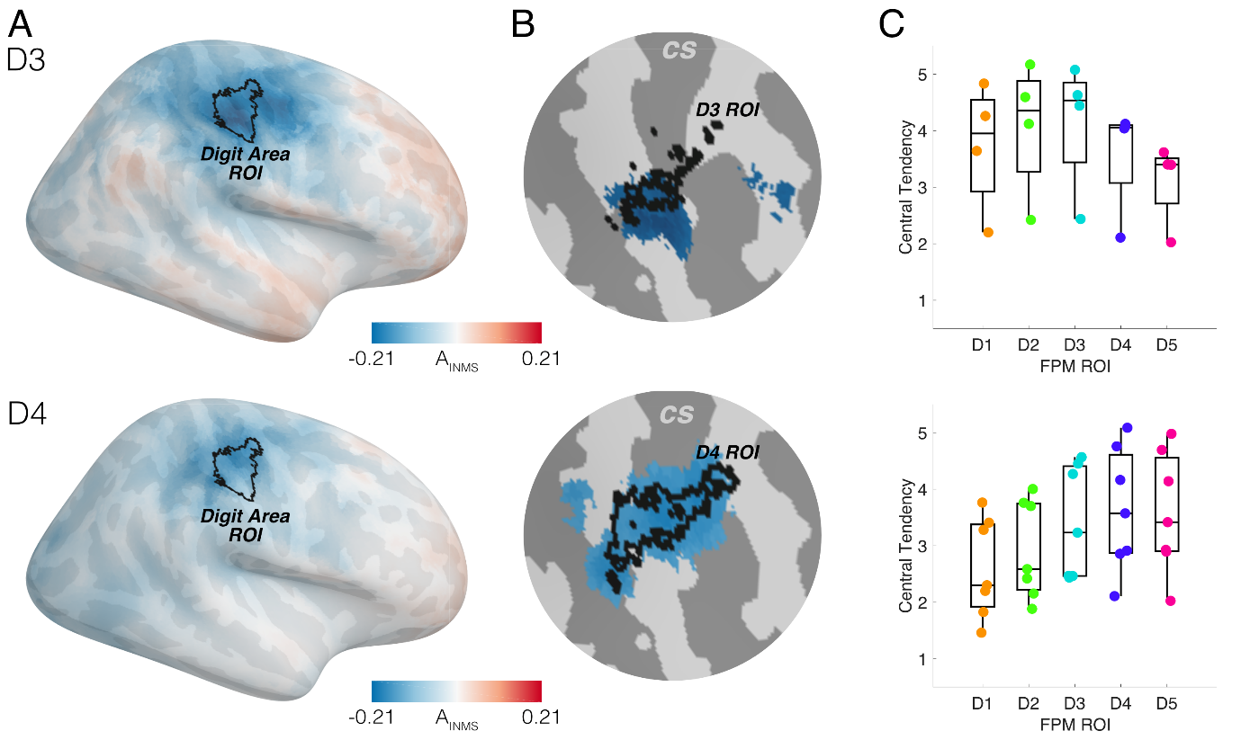

**Figure A1:** The application of the atlas to verify findings from a somatosensory study using MEG. A) The unthrehsolded, group-averaged functional activation images from experiments stimulating left D3 (top row) and left D4 (bottom row) showing the reduction of beta (13-30 Hz) oscillations during stimulation. The Digit Area ROI is shown in black for reference. B) Zoomed in representations of the central sulcus, with an arbitrary threshold of 80% applied to the functional images and the corresponding digit ROI as according the MPM atlas in black. C) The quantification of the central tendency scores within each of the atlas MPM ROIs for each experiment. Here we see that the experiment-median result is correctly identified to be highest within the ROI corresponding to the digit stimulated in both subsets of experiments, implying the maximal reduction of beta power is specific to the digit simulated.

**References**

Akselrod, M., Martuzzi, R., Serino, A., van der Zwaag, W., Gassert, R., Blanke, O., 2017. Anatomical and functional properties of the foot and leg representation in areas 3b, 1 and 2 of primary somatosensory cortex in humans: A 7T fMRI study. Neuroimage 159, 473–487. https://doi.org/10.1016/j.neuroimage.2017.06.021

Aquino, K.M., Sokoliuk, R., Pakenham, D.O., Sanchez‐Panchuelo, R.M., Hanslmayr, S., Mayhew, S.D., Mullinger, K.J., Francis, S.T., 2019. Addressing challenges of high spatial resolution UHF fMRI for group analysis of higher‐order cognitive tasks: An inter‐sensory task directing attention between visual and somatosensory domains. Hum. Brain Mapp. 40, 1298–1316. https://doi.org/10.1002/hbm.24450

Barratt, E.L., 2018. Multimodal Imaging of the Sensorimotor System. University of Nottingham.

Berens, P., 2015. CircStat : A MATLAB Toolbox for Circular Statistics . J. Stat. Softw. https://doi.org/10.18637/jss.v031.i10

Besle, J., Sánchez-Panchuelo, R.-M., Bowtell, R., Francis, S., Schluppeck, D., 2013. Single-subject fMRI mapping at 7 T of the representation of fingertips in S1: a comparison of event-related and phase-encoding designs. J. Neurophysiol. 109, 2293–2305. https://doi.org/10.1152/jn.00499.2012

Besle, J., Sánchez-Panchuelo, R.M., Bowtell, R., Francis, S., Schluppeck, D., 2014. Event-related fMRI at 7T reveals overlapping cortical representations for adjacent fingertips in S1 of individual subjects. Hum. Brain Mapp. https://doi.org/10.1002/hbm.22310

Brookes, M.J., Vrba, J., Robinson, S.E., Stevenson, C.M., Peters, A.M., Barnes, G.R., Hillebrand, A., Morris, P.G., 2008. Optimising experimental design for MEG beamformer imaging. Neuroimage 39, 1788–1802.

Cheyne, D.O., 2013. MEG studies of sensorimotor rhythms: A review. Exp. Neurol. https://doi.org/10.1016/j.expneurol.2012.08.030

Collins, D.L., Neelin, P., Peters, T.M., Evans, A.C., 1994. Automatic 3D Intersubject Registration of MR Volumetric Data in Standardized Talairach Space. J. Comput. Assist. Tomogr. 18, 192–205. https://doi.org/10.1097/00004728-199403000-00005

Da Costa, S., van der Zwaag, W., Marques, J.P., Frackowiak, R.S.J., Clarke, S., Saenz, M., 2011. Human Primary Auditory Cortex Follows the Shape of Heschl’s Gyrus. J. Neurosci. 31, 14067–14075. https://doi.org/10.1523/JNEUROSCI.2000-11.2011

Dale, A.M., Fischl, B., Sereno, M.I., 1999. Cortical surface-based analysis: I. Segmentation and surface reconstruction. Neuroimage 9, 179–194. https://doi.org/10.1006/nimg.1998.0395

DeYoe, E.A., Carman, G.J., Bandettini, P., Glickman, S., Wieser, J., Cox, R., Miller, D., Neitz, J., 1996. Mapping striate and extrastriate visual areas in human cerebral cortex. Proc. Natl. Acad. Sci. U. S. A. 93, 2382–6. https://doi.org/10.1073/PNAS.93.6.2382

Durand, D., Greenwood, J.A., 1958. Modifications of the Rayleigh Test for Uniformity in Analysis of Two-Dimensional Orientation Data. J. Geol. 66, 229–238. https://doi.org/10.1086/626501

Eickhoff, S.B., Paus, T., Caspers, S., Grosbras, M.H., Evans, A.C., Zilles, K., Amunts, K., 2007. Assignment of functional activations to probabilistic cytoarchitectonic areas revisited. Neuroimage. https://doi.org/10.1016/j.neuroimage.2007.03.060

Engel, S., 1997. Retinotopic organization in human visual cortex and the spatial precision of functional MRI. Cereb. Cortex 7, 181–192. https://doi.org/10.1093/cercor/7.2.181

Fischl, B., Rajendran, N., Busa, E., Augustinack, J., Hinds, O., Yeo, B.T.T., Mohlberg, H., Amunts, K., Zilles, K., 2008. Cortical folding patterns and predicting cytoarchitecture. Cereb. Cortex. https://doi.org/10.1093/cercor/bhm225

Fischl, B., Sereno, M.I., Dale, A.M., 1999a. Cortical surface-based analysis: II. Inflation, flattening, and a surface-based coordinate system. Neuroimage. https://doi.org/10.1006/nimg.1998.0396

Fischl, B., Sereno, M.I., Tootell, R.B.H., Dale, A.M., 1999b. High-resolution intersubject averaging and a coordinate system for the cortical surface. Hum. Brain Mapp. 8, 272–284. https://doi.org/10.1002/(SICI)1097-0193(1999)8:4<272::AID-HBM10>3.0.CO;2-4

Formisano, E., Kim, D.S., Di Salle, F., van de Moortele, P.F., Ugurbil, K., Goebel, R., 2003. Mirror-symmetric tonotopic maps in human primary auditory cortex. Neuron 40, 859–69.

Francis, S.T., Kelly, E.F., Bowtell, R., Dunseath, W.J.R., Folger, S.E., McGlone, F., 2000. fMRI of the responses to vibratory stimulation of digit tips. Neuroimage. https://doi.org/10.1006/nimg.2000.0541

Gelnar, P.A., Krauss, B.R., Szeverenyi, N.M., Apkarian, A.V., 1998. Fingertip Representation in the Human Somatosensory Cortex: An fMRI Study. Neuroimage 7, 261–283. https://doi.org/10.1006/nimg.1998.0341

Geyer, S., Schormann, T., Mohlberg, H., Zilles, K., 2000. Areas 3a, 3b, and 1 of Human Primary Somatosensory Cortex. Neuroimage 11, 684–696. https://doi.org/10.1006/nimg.2000.0548

Glover, P.M., Watkins, R.H., O’Neill, G.C., Ackerley, R., Sanchez-Panchuelo, R., McGlone, F., Brookes, M.J., Wessberg, J., Francis, S.T., 2017. An intra-neural microstimulation system for ultra-high field magnetic resonance imaging and magnetoencephalography. J. Neurosci. Methods 290. https://doi.org/10.1016/j.jneumeth.2017.07.016

Granga Espiritu Santo, M., 2018. Brain Imaging Exploration of the Representational Structures Supporting Observation of Abnormal Finger Postures. University of Nottingham.

Hari, R., Salmelin, R., 1997. Human cortical oscillation: a neuromagnetic view through the skull. Trends Neurosci. 20, 44–49. https://doi.org/10.1016/S0166-2236(96)10065-5

Hill, R.M., Holmes, N., Boto, E., Hartley, C., Leggett, J., Roberts, G., Shah, V., Tierney, T.M., Woolrich, M., Barnes, G.R., Bowtell, R., Slater, R., Brookes, M.J., 2019. A new tool for paediatric functional brain imaging. Nat. Commun. Under Revi.

Hou, P., Hasan, K.M., Sitton, C.W., Wolinsky, J.S., Narayana, P.A., 2005. Phase-sensitive T1 inversion recovery imaging: a time-efficient interleaved technique for improved tissue contrast in neuroimaging. AJNR. Am. J. Neuroradiol. 26, 1432–8.

Huang, R.-S., Sereno, M.I., 2007. Dodecapus: An MR-compatible system for somatosensory stimulation. Neuroimage 34, 1060–1073. https://doi.org/10.1016/j.neuroimage.2006.10.024

Hurley, A.C., Al-Radaideh, A., Bai, L., Aickelin, U., Coxon, R., Glover, P., Gowland, P.A., 2009. Tailored RF pulse for magnetization inversion at ultrahigh field. Magn. Reson. Med. NA-NA. https://doi.org/10.1002/mrm.22167

Jamali, S., Ross, B., 2013. Somatotopic finger mapping using MEG: Toward an optimal stimulation paradigm. Clin. Neurophysiol. 124, 1659–1670. https://doi.org/10.1016/j.clinph.2013.01.027

Jenkinson, M., Bannister, P., Brady, M., Smith, S., 2002. Improved optimization for the robust and accurate linear registration and motion correction of brain images. Neuroimage 17, 825–41.

Jenkinson, M., Smith, S., 2001. A global optimisation method for robust affine registration of brain images. Med. Image Anal. https://doi.org/10.1016/S1361-8415(01)00036-6

Kurth, R., Villringer, K., Curio, G., Wolf, K.-J., Krause, T., Repenthin, J., Schwiemann, J., Deuchert, M., Villringer, A., 2000. fMRI shows multiple somatotopic digit representations in human primary somatosensory cortex. Neuroreport 11, 1487–1491. https://doi.org/10.1097/00001756-200005150-00026

Lerch, J.P., van der Kouwe, A.J.W., Raznahan, A., Paus, T., Johansen-Berg, H., Miller, K.L., Smith, S.M., Fischl, B., Sotiropoulos, S.N., 2017. Studying neuroanatomy using MRI. Nat. Neurosci. 20, 314–326. https://doi.org/10.1038/nn.4501

Martuzzi, R., van der Zwaag, W., Farthouat, J., Gruetter, R., Blanke, O., 2014. Human finger somatotopy in areas 3b, 1, and 2: A 7T fMRI study using a natural stimulus. Hum. Brain Mapp. 35, 213–226. https://doi.org/10.1002/hbm.22172

Meunier, S., Garnero, L., Ducorps, A., Mazières, L., Lehéricy, S., Tézenas Du Montcel, S., Renault, B., Vidailhet, M., 2001. Human brain mapping in dystonia reveals both endophenotypic traits and adaptive reorganization. Ann. Neurol. 50, 521–527. https://doi.org/10.1002/ana.1234

Moerel, M., De Martino, F., Formisano, E., 2012. Processing of Natural Sounds in Human Auditory Cortex: Tonotopy, Spectral Tuning, and Relation to Voice Sensitivity. J. Neurosci. 32, 14205–14216. https://doi.org/10.1523/JNEUROSCI.1388-12.2012

Moerel, M., De Martino, F., Kemper, V.G., Schmitter, S., Vu, A.T., Uğurbil, K., Formisano, E., Yacoub, E., 2018. Sensitivity and specificity considerations for fMRI encoding, decoding, and mapping of auditory cortex at ultra-high field. Neuroimage 164, 18–31. https://doi.org/10.1016/j.neuroimage.2017.03.063

Mougin, O., Abdel-Fahim, R., Dineen, R., Pitiot, A., Evangelou, N., Gowland, P., 2016. Imaging gray matter with concomitant null point imaging from the phase sensitive inversion recovery sequence. Magn. Reson. Med. 76, 1512–1516. https://doi.org/10.1002/mrm.26061

Nakamura, A., Yamada, T., Goto, A., Kato, T., Ito, K., Abe, Y., Kachi, T., Kakigi, R., 1998. Somatosensory Homunculus as Drawn by MEG. Neuroimage 7, 377–386. https://doi.org/10.1006/nimg.1998.0332

Nelson, A.J., Chen, R., 2008. Digit somatotopy within cortical areas of the postcentral gyrus in humans. Cereb. Cortex. https://doi.org/10.1093/cercor/bhm257

Nestares, O., Heeger, D.J., 2000. Robust multiresolution alignment of MRI brain volumes. Magn. Reson. Med. 43, 705–715. https://doi.org/10.1002/(SICI)1522-2594(200005)43:5<705::AID-MRM13>3.0.CO;2-R

O’Neill, G.C., Watkins, R.H., Ackerley, R., Barratt, E.L., Sengupta, A., Asghar, M., Sanchez Panchuelo, R.M., Brookes, M.J., Glover, P.M., Wessberg, J., Francis, S.T., 2019. Imaging human cortical responses to intraneural microstimulation using magnetoencephalography. Neuroimage 189, 329–340. https://doi.org/10.1016/j.neuroimage.2019.01.017

Oldfield, R.C., 1971. The assessment and analysis of handedness: The Edinburgh inventory. Neuropsychologia. https://doi.org/10.1016/0028-3932(71)90067-4

Overduin, S.A., Servos, P., 2004. Distributed digit somatotopy in primary somatosensory cortex. Neuroimage. https://doi.org/10.1016/j.neuroimage.2004.06.024

Saenz, M., Langers, D.R.M., 2014. Tonotopic mapping of human auditory cortex. Hear. Res. 307, 42–52. https://doi.org/10.1016/j.heares.2013.07.016

Sanchez Panchuelo, R.M., Ackerley, R., Glover, P.M., Bowtell, R.W., Wessberg, J., Francis, S.T., McGlone, F., 2016. Mapping quantal touch using 7 Tesla functional magnetic resonance imaging and single-unit intraneural microstimulation. Elife 5, e12812.

Sanchez Panchuelo, R.M., Besle, J., Schluppeck, D., Humberstone, M., Francis, S., 2018. Somatotopy in the Human Somatosensory System. Front. Hum. Neurosci. 12, 235. https://doi.org/10.3389/fnhum.2018.00235

Sanchez Panchuelo, R.M., Francis, S., Bowtell, R., Schluppeck, D., 2010. Mapping Human Somatosensory Cortex in Individual Subjects With 7T Functional MRI. J. Neurophysiol. 103, 2544–2556. https://doi.org/10.1152/jn.01017.2009

Schweisfurth, M.A., Frahm, J., Schweizer, R., 2015. Individual left-hand and right-hand intra-digit representations in human primary somatosensory cortex. Eur. J. Neurosci. https://doi.org/10.1111/ejn.12978

Schweisfurth, M.A., Frahm, J., Schweizer, R., 2014. Individual fMRI maps of all phalanges and digit bases of all fingers in human primary somatosensory cortex. Front. Hum. Neurosci. 8, 658. https://doi.org/10.3389/fnhum.2014.00658

Sereno, M., Dale, A., Reppas, J., Kwong, K., Belliveau, J., Brady, T., Rosen, B., Tootell, R., 1995. Borders of multiple visual areas in humans revealed by functional magnetic resonance imaging. Science (80-. ). 268, 889–893. https://doi.org/10.1126/science.7754376

Stenroos, M., Nummenmaa, A., 2016. Incorporating and Compensating Cerebrospinal Fluid in Surface-Based Forward Models of Magneto- and Electroencephalography. PLoS One 11, e0159595. https://doi.org/10.1371/journal.pone.0159595

Stringer, E.A., Chen, L.M., Friedman, R.M., Gatenby, C., Gore, J.C., 2011. Differentiation of somatosensory cortices by high-resolution fMRI at 7T. Neuroimage 54, 1012–1020. https://doi.org/10.1016/j.neuroimage.2010.09.058

Torebjörk, H.E., Ochoa, J.L., 1980. Specific sensations evoked by activity in single identified sensory units in man. Acta Physiol. Scand. 110, 445–447. https://doi.org/10.1111/j.1748-1716.1980.tb06695.x

Trulsson, M., Francis, S.T., Kelly, E.F., Westling, G., Bowtell, R., McGlone, F., 2001. Cortical responses to single mechanoreceptive afferent microstimulation revealed with fMRI. Neuroimage 13, 613–622.

Vallbo, Å.B., 1981. Sensations evoked from the glabrous skin of the human hand by electrical stimulation of unitary mechanosensitive afferents. Brain Res. 215, 359–363. https://doi.org/10.1016/0006-8993(81)90517-5

Van de Moortele, P.F., Auerbach, E.J., Olman, C., Yacoub, E., Uǧurbil, K., Moeller, S., 2009. T1 weighted brain images at 7 Tesla unbiased for Proton Density, T2 * contrast and RF coil receive B1 sensitivity with simultaneous vessel visualization. Neuroimage. https://doi.org/10.1016/j.neuroimage.2009.02.009

van der Zwaag, W., Gruetter, R., Martuzzi, R., 2015. Stroking or Buzzing? A Comparison of Somatosensory Touch Stimuli Using 7 Tesla fMRI. PLoS One 10, e0134610. https://doi.org/10.1371/journal.pone.0134610

Wandell, B.A., Dumoulin, S.O., Brewer, A.A., 2007. Visual Field Maps in Human Cortex. Neuron 56, 366–383. https://doi.org/10.1016/j.neuron.2007.10.012

Wang, L., Mruczek, R.E.B., Arcaro, M.J., Kastner, S., 2015. Probabilistic Maps of Visual Topography in Human Cortex. Cereb. Cortex 25, 3911–3931. https://doi.org/10.1093/cercor/bhu277

Weibull, A., Björkman, A., Hall, H., Rosén, B., Lundborg, G., Svensson, J., 2008. Optimizing the mapping of finger areas in primary somatosensory cortex using functional MRI. Magn. Reson. Imaging. https://doi.org/10.1016/j.mri.2008.04.007

1. This step may perhaps seem over-engineered given that we could use FSL’s brain extraction tool (*BET*) on the anatomical image to perform the same procedure. However, we found that using BET with default parameters would often erroneously remove large volumes of cortex, whereas Freesurfer’s output was far more reliable when unsupervised. The rigid body transform to the MPRAGE space ensured the voxel padding introduced to the images in Freesurfer did not cause any unforeseen issues with voxel-to-voxel registrations further down the pipeline.